**TEAM5OARS chat tutorial**

1. **Go to purechat.com, and click on “Sign up.” Enter your details in the registration form and click “Sign Up”**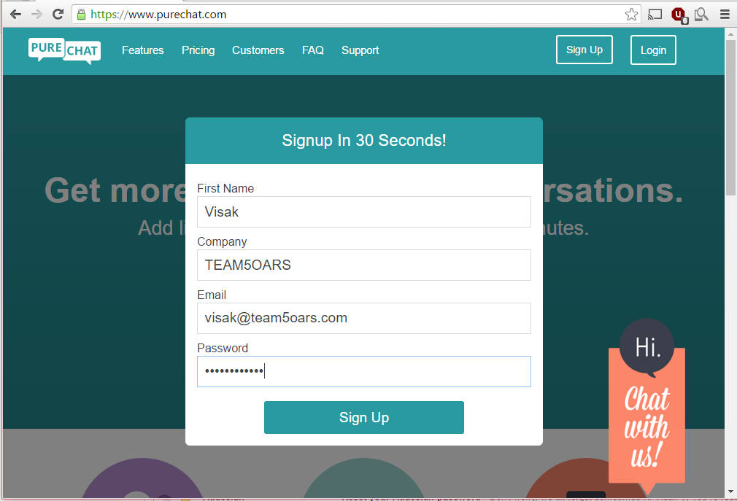
2. **Scroll down and copy the code from the section labeled “Add Code To Your Website On Your Own”**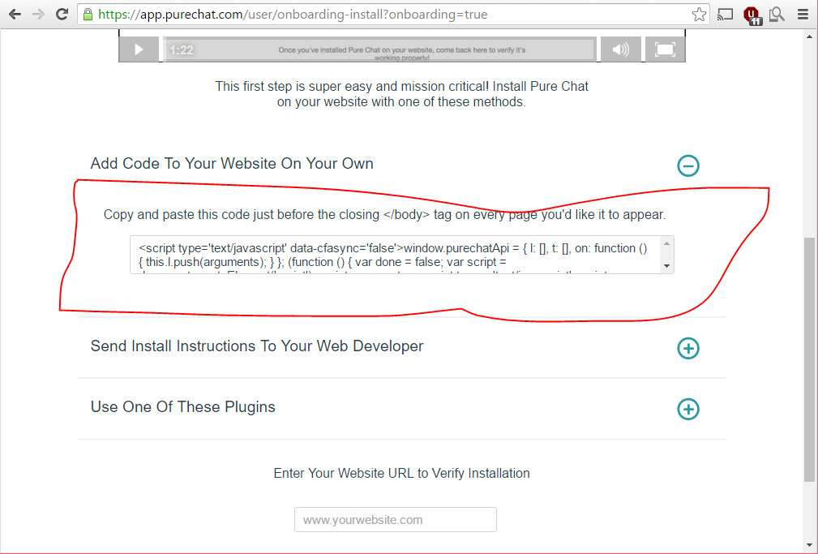
3. **Insert that code before the </body> on every page you want the chat box to appear on.**

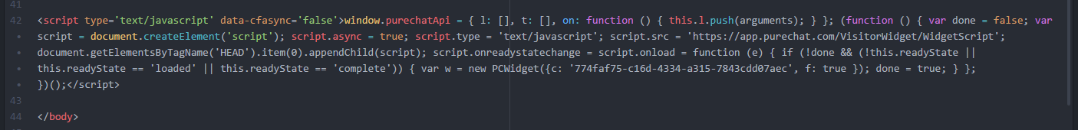

1. **Now go to app.purechat.com and you’ll see all incoming chats on the left side of the navigation bar. At this point the chat bar should appear on your website at the bottom right.**

